**Crime Analysis**

The data is about the crime records of the state LA in USA. The data consists of different crime activities recorded for the time period 2011-2021. Which has the defined the crime category and area of the crime scene.

**Analyzing of the Data using Graphs:**

* 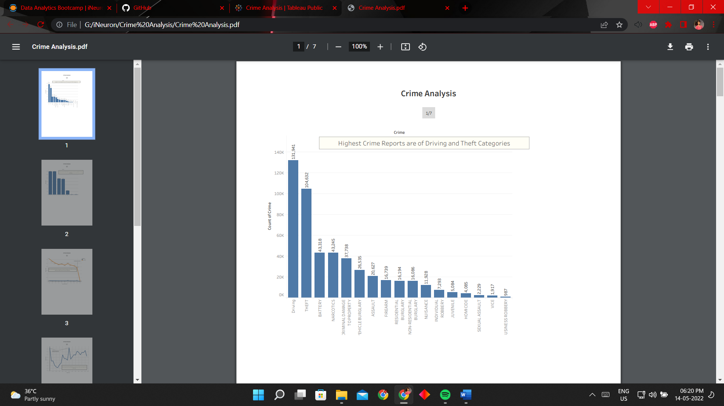The following plot between Crime categories and crime records count. We can observe that the highest crime category recorded are of Driving and Theft cases. Driving includes speeding and drunk-and-drive and Theft includes Vehicles, Residential and non-Residentials.
* Chart

  Description automatically generatedThe following plot between Districts and crime records count. We can Observe that District 2 and 1 has highest of total crime records.
* The following plot between year and crime records count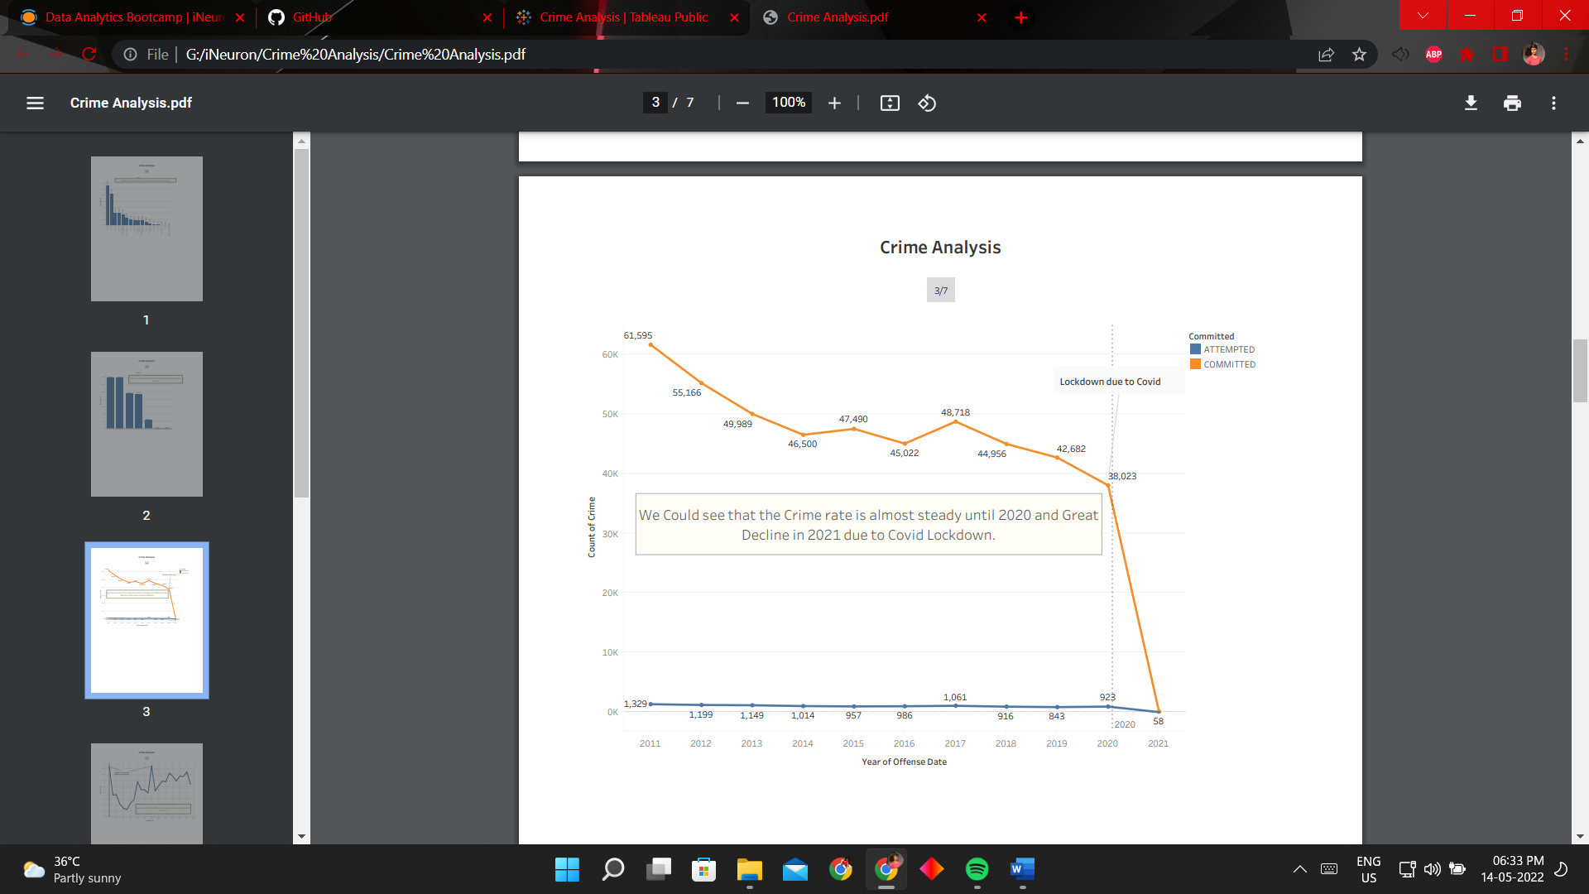. We can see that there is drastical decline of crime rate from 2020-2021 due to Covid19 Lockdown.
* The following plot between time of the day and crime records count. We can observe that the frequenct crime activity is from afternoon to Mid Night and is highest at Midnight and at Noon.

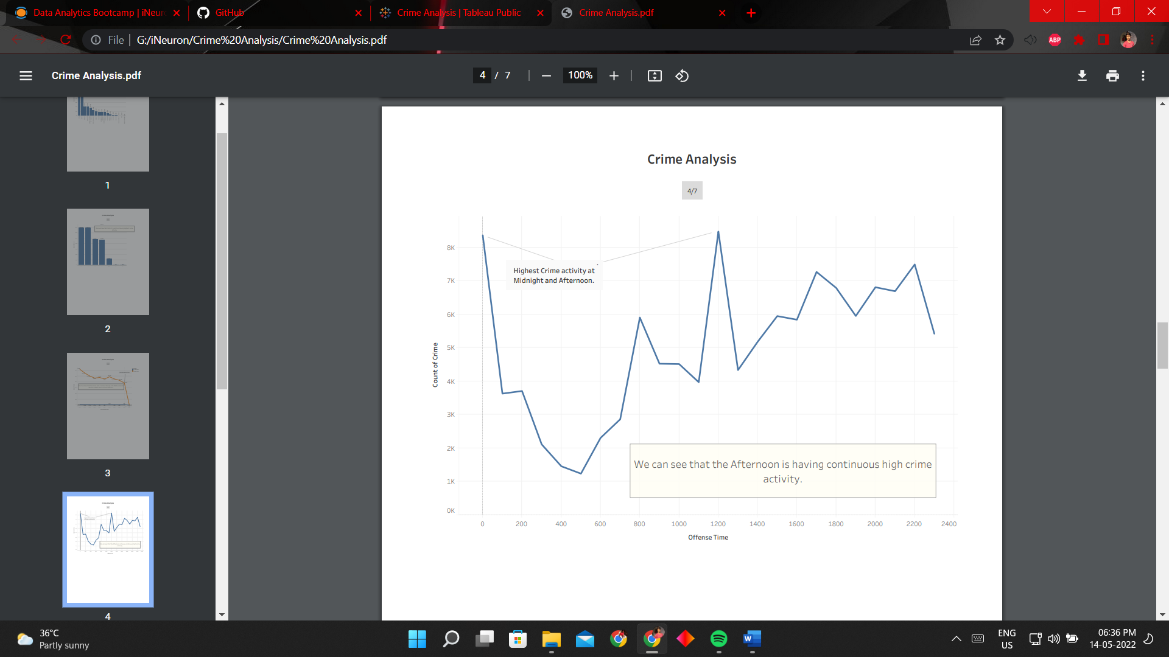

* 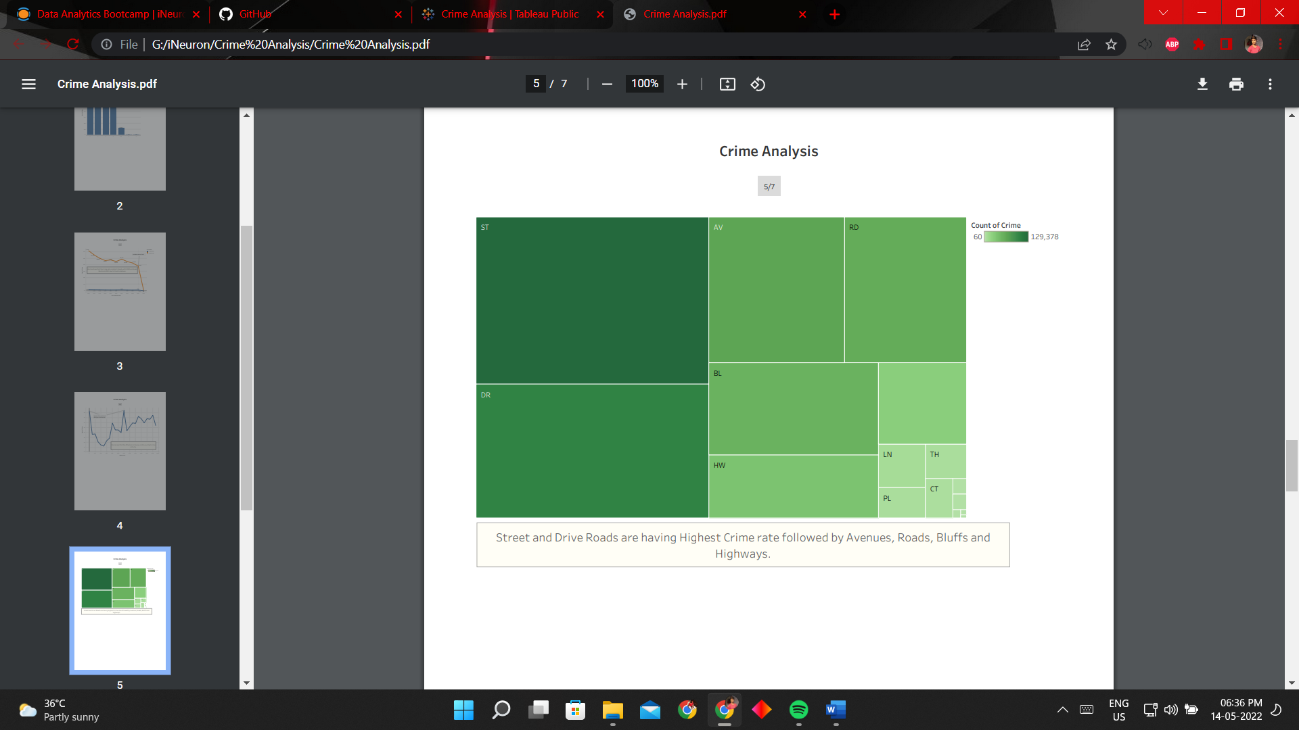The following plot between street type and crime records count. We can the Streets and Local roads are having crime rate which are followed by the Avenues, City Roads, Bluffs and Highways.
* A screenshot of a computer

  Description automatically generatedThe following plot between Month and crime records count categorized by Districts. We can observe that districts 1 and 2 are having the highest crime rate though the Year.
* The following Pie chart of Zonal Crime rate Analysis shows that the Zone **C** is having the highest crime rate in the police sectors.

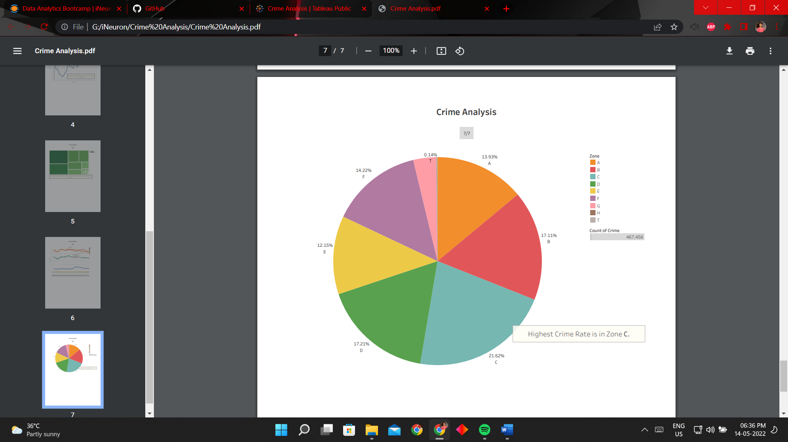

**Inference from the Analysis:**

1. Careless Driving is causing the major crime records in the state LA in USA. The state needs is take severe actions against the careless drivers. Also, Theft cases are high in the state. The patrol needs to incresed and security camers needs to be installed in public places and streets.
2. Districts 1 and 2 are showing the highest crime rate. The police security and security strength needs to incresed in the districts.
3. There is a drastical decline in the criminal activities from 2020-2021 due to Covid19 Lockdown.
4. The security needs to incresed in the C,D and B zones immediately as they are the hotspot criminal activity zones.
5. Most of the Criminal activities are frequent from afternoon to midnight. Patrol needs to be increased in this time period.
6. The security cameras needs to be incresed in local streets and roads as they were the major crime scenes.
7. Increasing the security cameras and patrolling will reduce the major categories of crime like Driving, Theft, Battery, Damage to property and Sexual Assualt.